

COMPUTER FUNDAMENTALS

**MID-TERM**



MUHAMMAD SIBTAIN

01-131232-068

Submitted to: Engr. Waleed Khan

**Introduction**:

We have a financial overview of the Investment Return of 10 days, in which we had ups and downs as expected in each business.

We have financial analysis of 10 days, in this financial analysis we have seen that we have average return of **$11,160.00** and investment return of **785.111457.**

**Summary**:

* In these 10 days we had average of $11,160.00 which is good average in 10 days for a company.
* In these 10 days we had investment return of 785.111457.
* Our company is touching the trends of market and having a good progress.

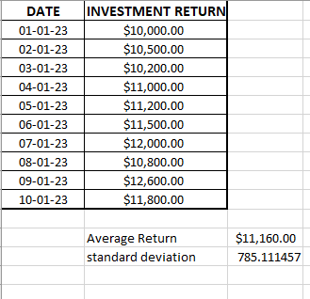

**Graph of Progress**:

